DIGI NURTURE 4.0
Unit Testing:
Exercise 1: Setting up Junit
Step 1:
Create a maven Project
Pom.xml:
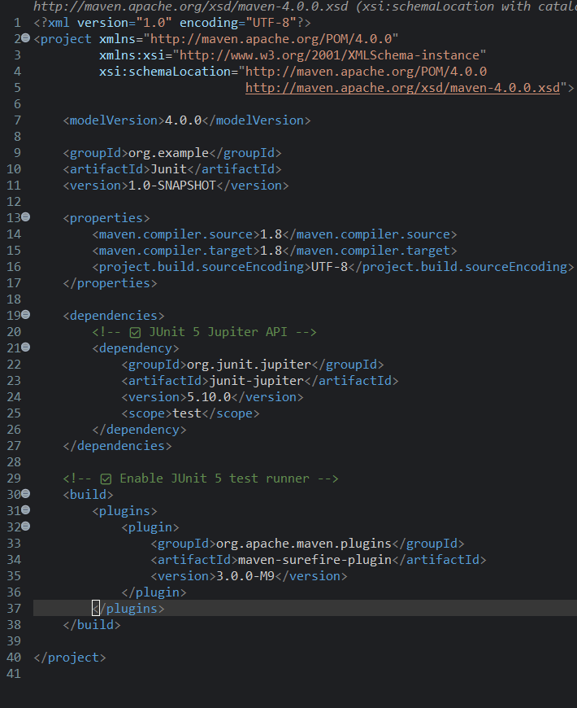

Step 2:
In src/test/java, Create class name CalculatorTest.java
package org.example;

import org.junit.jupiter.api.Test;
import static org.junit.jupiter.api.Assertions.*;

public class CalculatorTest {

@Test
void testAddition() {
int result = 10 + 5;
System.out.println("Running testAddition...");
System.out.println("Result of 10 + 5 is: " + result);
assertEquals(15, result);
System.out.println("testAddition passed\n");
}

@Test
void testDivisionByZero() {
System.out.println("Running testDivisionByZero...");
assertThrows(ArithmeticException.class, () -> {
int x = 1 / 0;
});
System.out.println("testDivisionByZero passed \n");
}
}

OUTPUT:
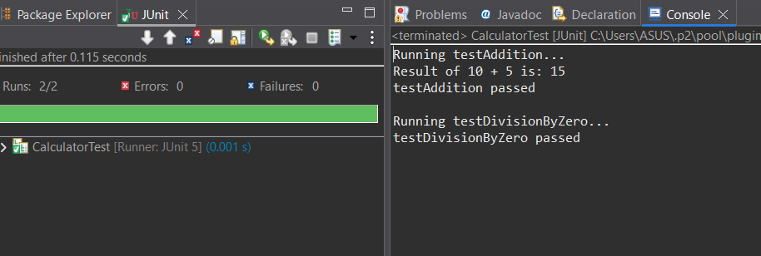

Exercise 3: Assertions in Junit
Step 1:
In src/test/java,Create java class named AssertionsTest.java.

Assertiontest.java

package org.example;
import org.junit.jupiter.api.Test;
import static org.junit.jupiter.api.Assertions.*;
public class assertionTest {
@Test
public void testAssertions() {

assertEquals(5,2+3);
System.out.println("checking asserts equals");

assertTrue(5 > 3);
System.out.println("checking assertTrue");

assertFalse(5 < 3);
System.out.println("Checking assertFalse");

assertNull(null);
System.out.println("Checking assertNull...");

assertNotNull(new Object());
System.out.println("Checking assertNotNull...");
}
}

OUTPUT:
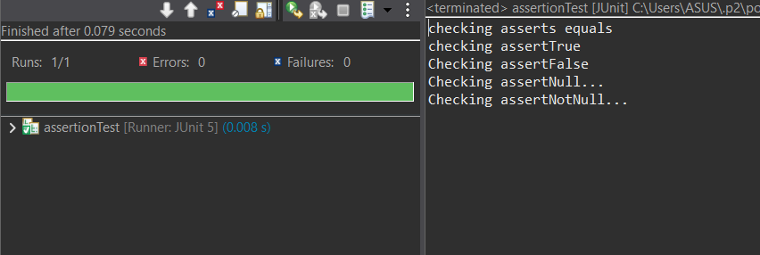
Exercise 4: Arrange-Act-Assert (AAA) Pattern, Test Fixtures, Setup and Teardown Methods in JUnit:

Step1 :
In src/test/java/org.example,create a class named Calculator.java.

package org.example;
public class Calculator {
public int add(int a, int b) {
return a + b;
}
}
Step 2:
In src/test/java/org.example,create a class named CalculatorTest.java.
package org.example;
import org.junit.jupiter.api.BeforeEach;
import org.junit.jupiter.api.AfterEach;
import org.junit.jupiter.api.Test;
import static org.junit.jupiter.api.Assertions.*;
public class CalculatorTest {
private Calculator calc;
@BeforeEach
public void setUp() {
System.out.println("Setup: Initializing Calculator");
calc = new Calculator();

@AfterEach
public void tearDown() {
System.out.println("Teardown: Nullifying Calculator");
calc = null;
}

@Test
public void testAddition() {
int a = 15;
int b = 20;
int result = calc.add(a, b);
assertEquals(35, result, "Addition should return");
}
}
OUTPUT
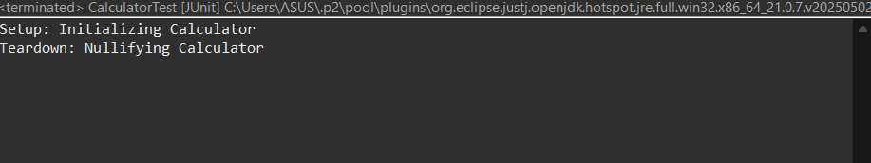
3.Mockito excersice:

Step 1:
Setup pom.xml
<project xmlns="http://maven.apache.org/POM/4.0.0"
xmlns:xsi="http://www.w3.org/2001/XMLSchema-instance"
xsi:schemaLocation="http://maven.apache.org/POM/4.0.0
http://maven.apache.org/xsd/maven-4.0.0.xsd">

<modelVersion>4.0.0</modelVersion>
<groupId>com.CTS</groupId>
<artifactId>MockitoTestProject</artifactId>
<version>1.0-SNAPSHOT</version>

<dependencies>

<dependency>
<groupId>org.junit.jupiter</groupId>
<artifactId>junit-jupiter-api</artifactId>
<version>5.7.1</version>
<scope>test</scope>
</dependency>

<dependency>
<groupId>org.junit.jupiter</groupId>
<artifactId>junit-jupiter-engine</artifactId>
<version>5.7.1</version>
<scope>test</scope>
</dependency>

<dependency>
<groupId>org.mockito</groupId>
<artifactId>mockito-core</artifactId>
<version>4.2.0</version>
<scope>test</scope>
</dependency>
</dependencies>

<build>
<plugins>
<plugin>
<groupId>org.apache.maven.plugins</groupId>
<artifactId>maven-surefire-plugin</artifactId>
<version>3.0.0-M8</version>
</plugin>
</plugins>
</build>
</project>
Step 2:
In src/test/java/org.example create an Interface named ExternalAPI.java
package org.example;

public interface ExternaAPI {
String getData();
}

Step 3:
In src/test/java/org.example create a Class Myservice.java
package org.example;

public class MyService {
private ExternalAPI api;

public MyService(ExternalAPI api) {
this.api = api;
}

public String fetchData() {
return api.getData();
}

}

Step 4:
In src/test/java/org.example,create a class named MyServiceTest.
package org.example;
import static org.mockito.Mockito.*;
import static org.junit.jupiter.api.Assertions.*;
import org.junit.jupiter.api.Test;
import org.mockito.Mockito;
public class MyServiceTest {
@Test
public void testExternalApi() {
ExternalAPI mockApi = Mockito.mock(ExternalAPI.class);
when(mockApi.getData()).thenReturn("Mock Data");
MyService service = new MyService(mockApi);
String result = service.fetchData();
assertEquals("Mock Data", result);
}
}
OUTPUT:
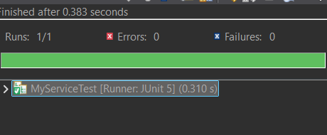

Exersice 2: Verifying Interaction
In src/test/java/org.example,create or alter a class named MyServiceTest.
package org.example;
import static org.mockito.Mockito.*;
import org.junit.jupiter.api.Test;
import org.mockito.Mockito;
public class MyServiceTest {
@Test
public void testVerifyInteraction() {
ExternalAPI mockApi = Mockito.mock(ExternalAPI.class);
MyService service = new MyService(mockApi);
service.fetchData();
verify(mockApi).getData();
}
}
OUTPUT:
